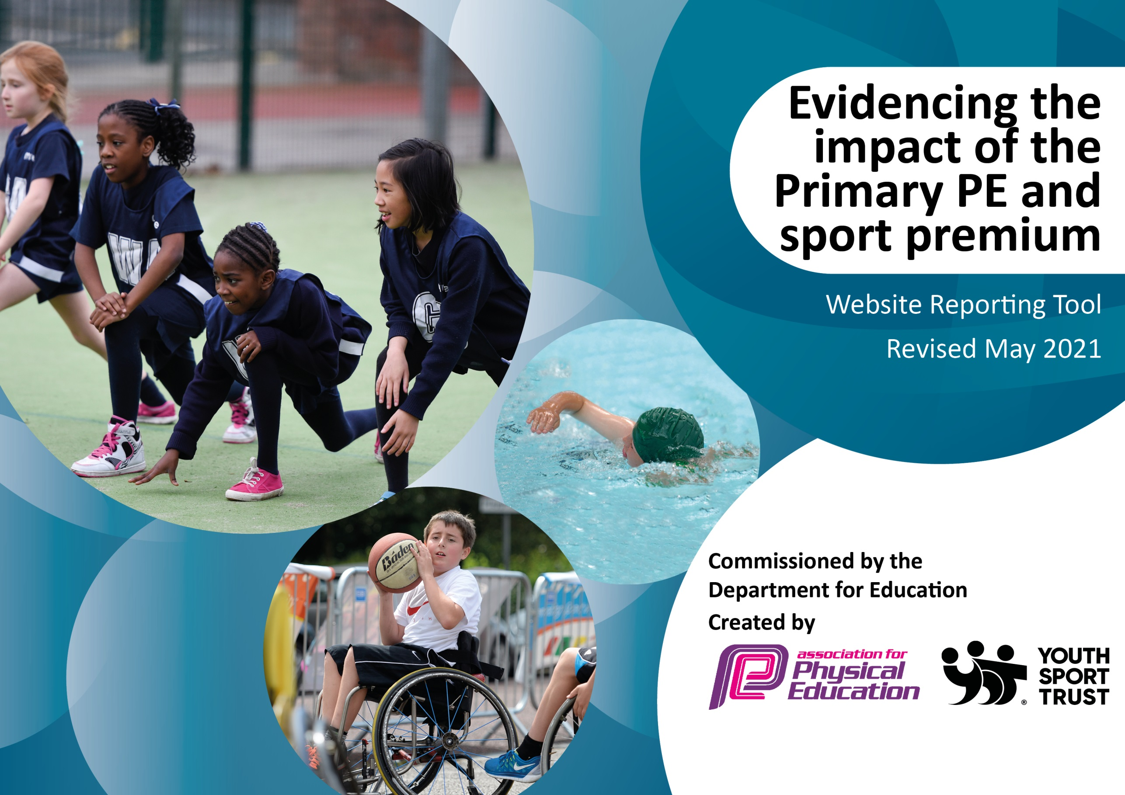

It is important that your grant is used effectively and based on school need. The Education Inspection Framework (Ofsted 2019 p64) makes clear there will be a focus on ‘whether leaders and those responsible for governors all understand their respective roles and perform these in a way that enhances the effectiveness of the school’.

Under the Quality of Education criteria (p41) inspectors consider the extent to which schools can articulate their curriculum (INTENT), construct their curriculum (IMPLEMENTATION) and demonstrate the outcomes which result (IMPACT).

To assist schools with common transferable language this template has been developed to utilise the same three headings which should make your plans easily transferable between working documents.

Schools must use the funding to make additional and sustainable improvements to the quality of Physical Education, School Sport and Physical Activity (PESSPA) they offer. This means that you should use the Primary PE and sport premium to:

- Develop or add to the PESSPA activities that your school already offer
- Build capacity and capability within the school to ensure that improvements made now will benefit pupils joining the school in future years
- The Primary PE and sport premium should not be used to fund capital spend projects; the school’s budget should fund these.
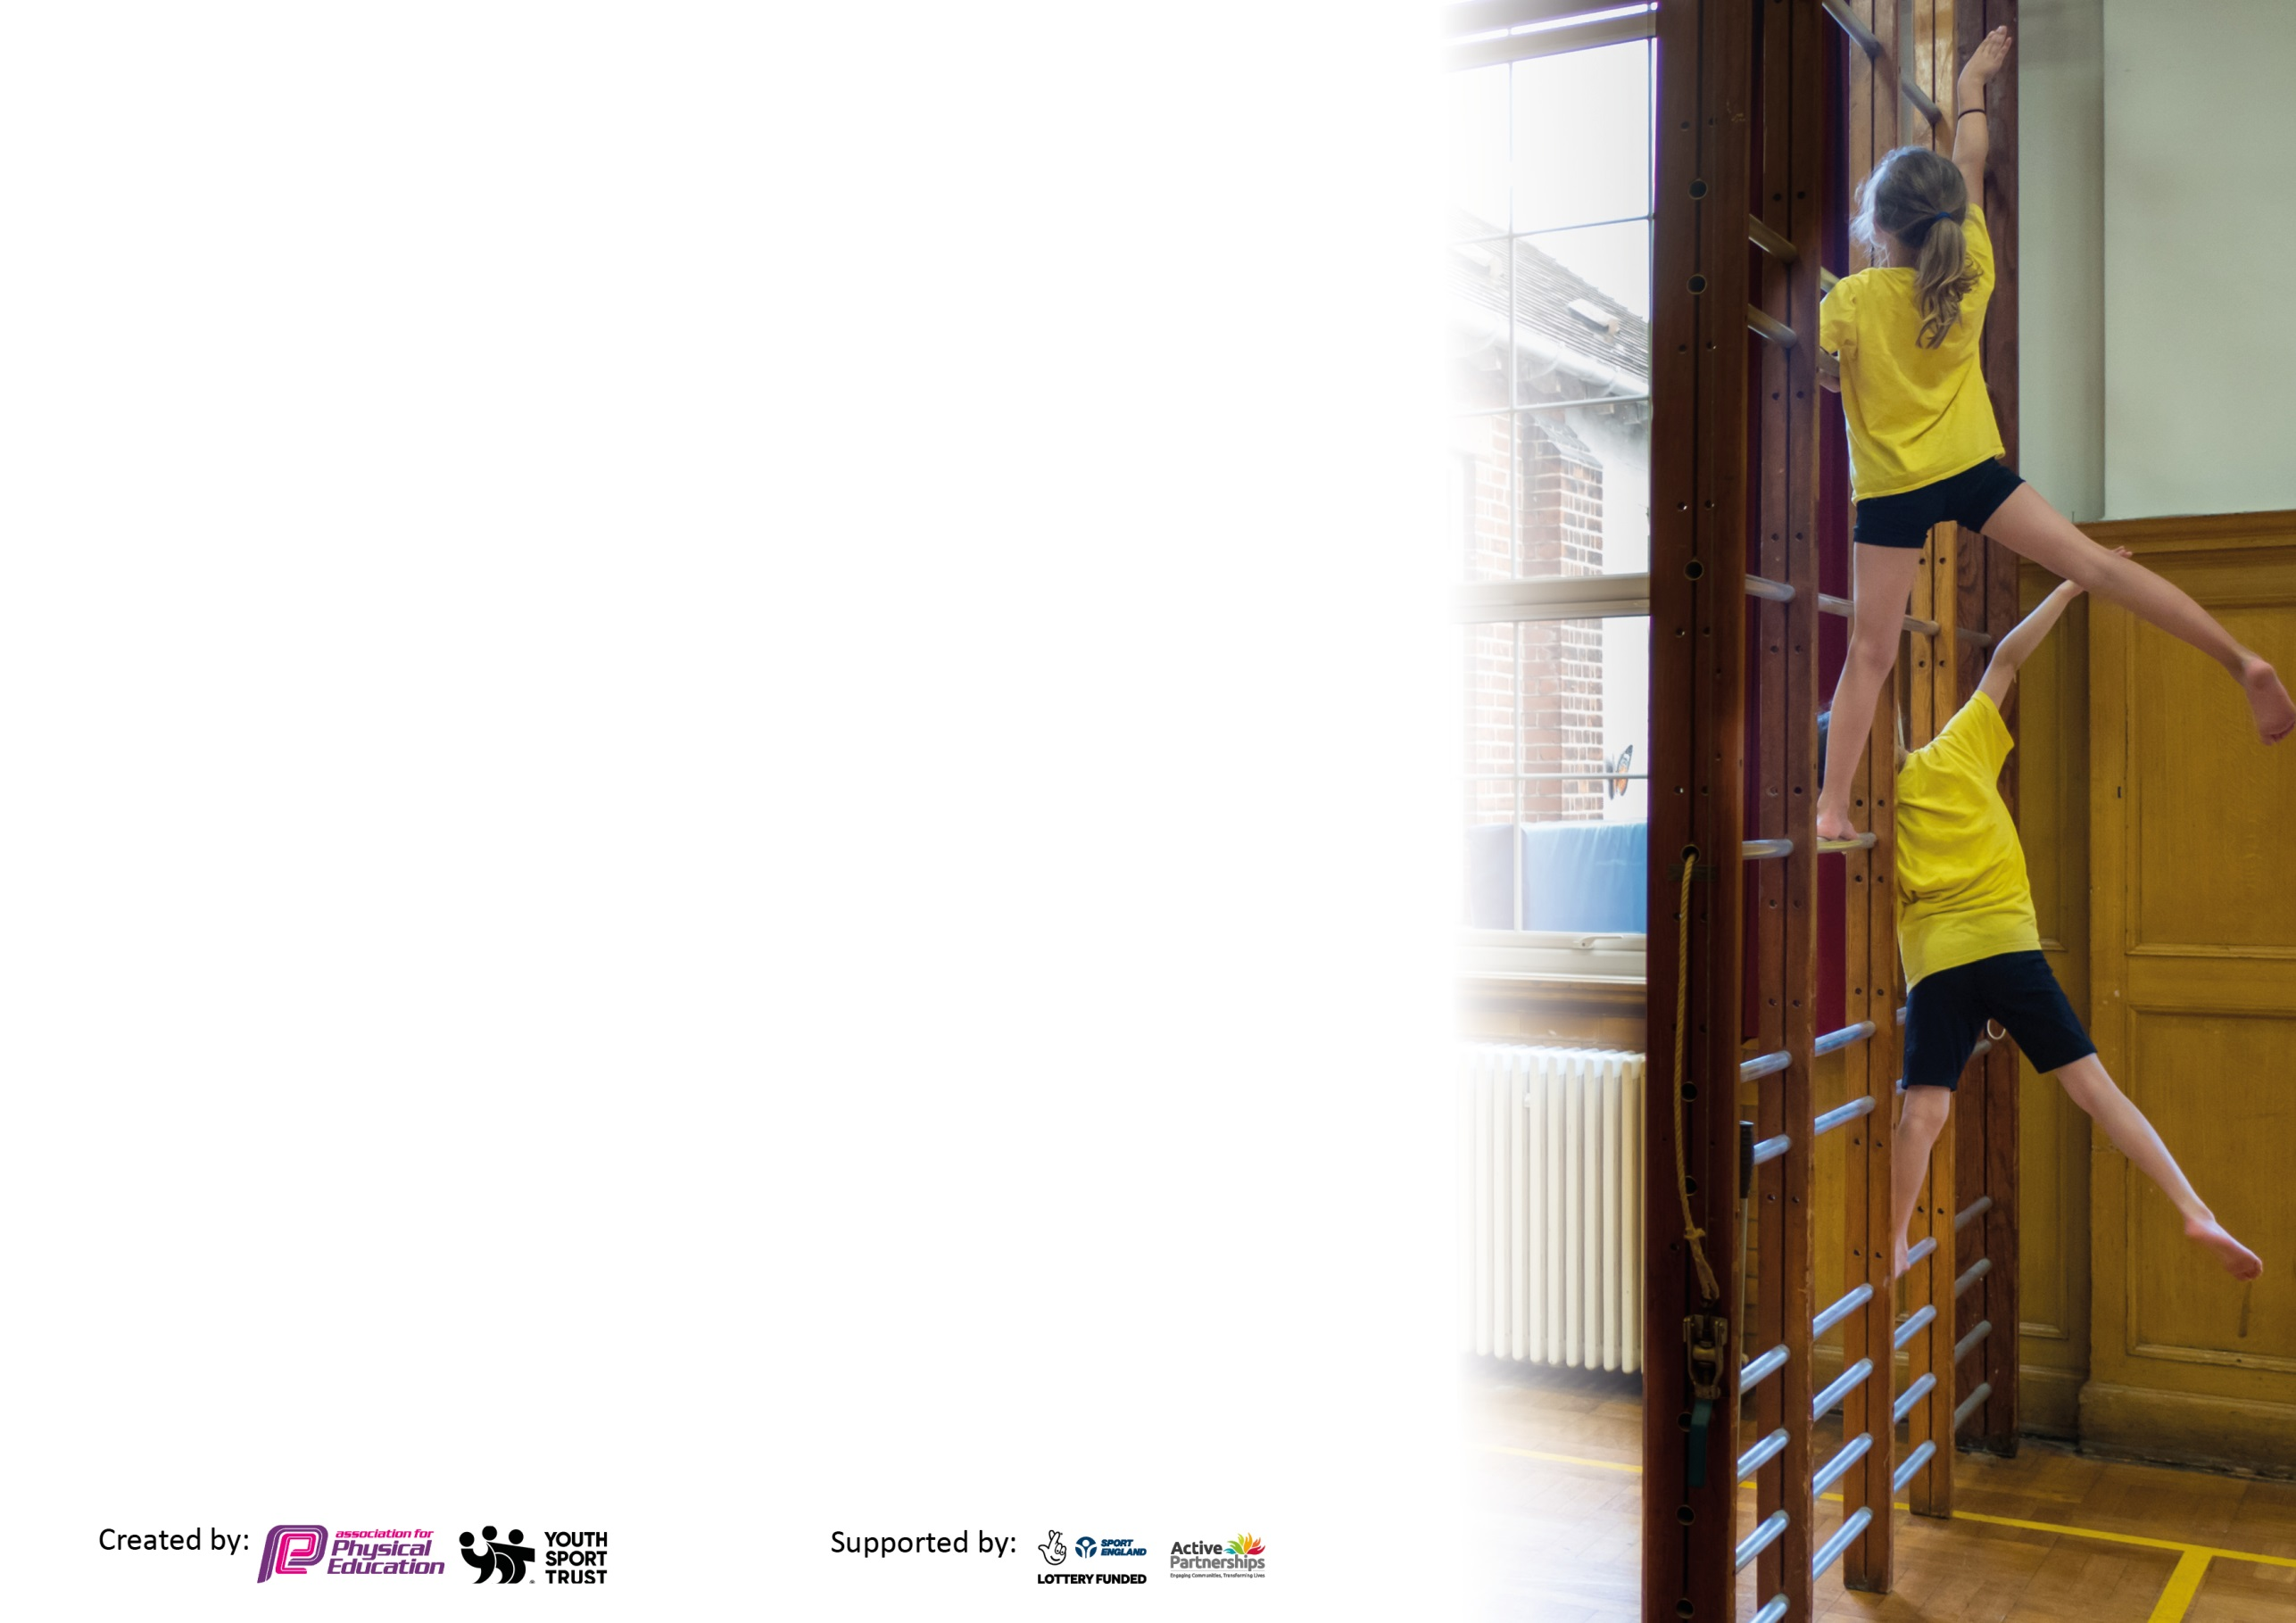
Please visit gov.uk for the revised DfE guidance including the 5 key indicators across which schools should demonstrate an improvement. This document will help you to review your provision and to report your spend. DfE encourages schools to use this template as an effective way of meeting the reporting requirements of the Primary PE and sport premium.

We recommend you start by reflecting on the impact of current provision and reviewing the previous spend.

Schools are required to publish details of how they spend this funding, including any under-spend from 2019/2020, as well as on the impact it has on pupils’ PE and sport participation and attainment by the end of the summer term or by 31st July 2021 at the latest.

We recommend regularly updating the table and publishing it on your website throughout the year. This evidences your ongoing self-evaluation of how you are using the funding to secure maximum, sustainable impact. Final copy must be posted on your website by the end of the academic year and no later than the 31st July 2021. To see an example of how to complete the table please click HERE.

Please note: Although there has been considerable disruption in 2020 it is important that you publish details on your website of how you spend the funding - this is a legal requirement.
Support for review and reflection - considering the 5 key indicators from DfE, what development needs are a priority for your setting and your pupils now and why? Use the space below to reflect on previous spend and key achievements and areas for development.

N.B. In this section you should refer to any adjustments you might have made due to Covid-19 and how these will influence further improvement.
Key achievements to date until July 2020: | Areas for further improvement and baseline evidence of need:
- Able to deliver our curriculum map with some minor amendments to ensure the integrity of our bubbles  - Introduced new sports day format which was popular with both staff and pupils and helped to raise the ‘value’ of sport in school  - New equipment in the playground has been popular and has increased activity levels  - ‘Daily Mile’ has been effective in increasing activity levels across the school, although not used daily  - Children have enjoyed a broader range of activities within the curriculum and been enthusiastic about taking part in dance and gymnastics  - Teachers now use detailed planning to support their lessons and have a broader understanding of the role of PE and how it supports learning across the three strands  - Teachers are growing in confidence in their teaching of PE and taking increasing ownership  - HLJs are beginning to provide detailed pupil voice information | - Increase the opportunities for intra and inter school competition. This has been dramatically impacted by Covid.  - Raise the profile of PE, Sport and Physical Activity across the school. PESSPA has been significantly affected by Covid due to the challenge of delivering virtual PE lessons and the ‘team’ nature of many of the activities. Further impact has come from the difficulties associated with managing infection risk and equipment use. The coming year will be an opportunity to focus on PESSPA as a tool for supporting children’s physical, social, emotional and mental health and wellbeing, and their recovery from the pandemic.  - Increase children’s physical activity levels to ensure that we are delivering ’30 Active minutes’ each school day - Covid has significantly impacted on the clubs that the school have been able to provide. Re-establishing a thriving after school programme will be a focus for the coming year.

Did you carry forward an underspend from 2019-20 academic year into the current academic year? YES/NO * Delete as applicable
Total amount carried forward from 2019/2020 £ 9352.53
+ Total amount for this academic year 2020/2021 £ 17392
= Total to be spent by 31st July 2021 £ 26 744.53

Meeting national curriculum requirements for swimming and water safety.

N.B Complete this section to your best ability. For example you might have practised safe self-rescue techniques on dry land which you can transfer to the pool when school swimming restarts.
Due to exceptional circumstances priority should be given to ensuring that pupils can perform safe self rescue even
if they do not fully meet the first two requirements of the NC programme of study.
What percentage of your current Year 6 cohort swim competently, confidently and proficiently over a distance of at least 25 metres?  N.B. Even though your pupils may swim in another year please report on their attainment on leaving primary school at the end of the summer term 2021.  Please see note above. | 90%
What percentage of your current Year 6 cohort use a range of strokes effectively [for example, front crawl, backstroke and breaststroke]?  Please see note above. | 80%
What percentage of your current Year 6 cohort perform safe self-rescue in different water-based situations? | 90%
Schools can choose to use the Primary PE and sport premium to provide additional provision for swimming but this must be for activity over and above the national curriculum requirements. Have you used it in this way? | Yes/No

Action Plan and Budget Tracking
Capture your intended annual spend against the 5 key indicators. Clarify the success criteria and evidence of impact that you intend to measure to evaluate for pupils today and for the future.

Academic Year: 2020/21 | Total fund allocated: £ | Date Updated:
Key indicator 1: The engagement of all pupils in regular physical activity – Chief Medical Officers guidelines recommend that primary school pupils undertake at least 30 minutes of physical activity a day in school |  |  |  | Percentage of total allocation:
 |  |  |  | %
Intent | Implementation |  | Impact | 40 (4)
Your school focus should be clear what you want the pupils to know and be able to do and about  what they need to learn and to  consolidate through practice: | Make sure your actions to achieve are linked to your intentions: | Funding allocated:  Actual | Evidence of impact: what do pupils now know and what can they now do? What has changed?: | Sustainability and suggested next steps:
To increase physical activity levels at playtime and lunchtime | - Recruit a team of PESS Monitors to support management of clubs and resources  - Establish playtime clubs that promote physical activity, social skills, positive mental health and problem solving  - Introduce ‘Challenge Week’ and work with Year 5/6 pupils to support  - Introduce the Hunton Mile Challenge  - Liaise with playground staff to ensure that appropriate systems are in place  - Purchase additional playground equipment and storage specifically for use at playtimes  - Implement system for equipment use and management at playtime  - Involve the school council in reviewing and developing the playground provision  - Involve children in development of new playground markings for the playground area  Introduce the Moki system to motivate children and facilitate learning about the benefits of PA | £100  £200  £2000  £860  £8000  £0  £500  £0 | Mar 21 update  Progress has been impacted by the lack of capacity in the school due to no substantive Head until Jan 21 and the subsequent national lockdown in term 3.  PESS Monitors to be in place in Term 5, with playtime clubs up and running then.  KS2 have been running a mile twice weekly in terms 1 and 2. This will also be further developed in term 5.  A large equipment order is planned but is currently awaiting confirmation of budget available.  July 21  Resources purchased and being used by children at lunch and playtimes, monitored by staff. Managed by pupils. Resources in place to extend the range of activities available in September to promote social skills etc. Storage shed in place with separate equipment for KS1 and 2 bubbles.  Moki system has been discarded due to negative reports from other schools. SD to review this aspect. | Playground markings will be done in the Autumn term with input from staff and children.  Playground to be divided to create a space for children to play football and other spaces for different types of play.  Further equipment to be purchased to increase activity levels.  Hunton Mile Challenge to be implemented in term 1
To develop targeted programmes to increase physical activity levels amongst inactive groups | - Gather information to identify which children are active through extra-curricular programmes and activities outside of school  - Triangulate data with teacher feedback and playground observations  - Identify inactive children and begin to track activity for this group  - Liaise with VP to arrange an opportunity for school council to do some research into what might encourage children to be more physically active.  - Use the information to plan targeted programmes |  | Mar 21 Update  These actions have not been completed due to the national lockdown.  During lockdown, pupils were supported to remain active through ‘Home learning PE Lessons’ and through the Sir Captain Tom Moore Challenge.  Jul 21  This are of work has been delayed due to capacity issues created by Covid.  Some children identified as inactive have been targeted for gardening sessions to increase PA. | School Council to be involved in planning further equipment purchases for the playground.  Physical Activity Leaders to be elected in the autumn term to take part in research into what the children would like to do.  Plans for inactive children to be introduced.
Key indicator 2: The profile of PESSPA being raised across the school as a tool for whole school improvement |  |  |  | Percentage of total allocation:
 |  |  |  | %
Intent | Implementation |  | Impact | 0 (0)
Your school focus should be clear what you want the pupils to know and be able to do and about  what they need to learn and to  consolidate through practice: | Make sure your actions to achieve are linked to your intentions: | Funding allocated: | Evidence of impact: what do pupils now know and what can they now do? What has changed?: | Sustainability and suggested next steps:
To develop the PE curriculum to include the explicit teaching of Physical / Cognitive and Social / Emotional skills | - Create a document detailing the progression of skills across the three strands  - Ensure that unit overviews detail the learning across the three strands  - Ensure that all lesson plans include development of skills relating to the three strands  - Introduce an assessment framework that enables teachers to track and progress across the three strands  - Develop links between social / emotional learning and the wider curriculum , particularly PSHE |  | Mar 21 Update  Class teachers received training on assessment in PE and an introduction to the new assessment framework.  Schemes of work have been purchased and the subject lead has begun to map these, alongside existing planning, using the new curriculum map and progression documents.  Work is ongoing to embed these and link to our three strand approach.  Jul 21  Progress has been impacted by capacity issues arising from Covid. Schemes of work fully in place. Mapping of three strands should be completed early next academic year. | Embedding of assessment framework and understanding of the teaching and learning across the three strands.  Further development of links between PE, SEMH, PSHE and the wider curriculum.
To integrate PESSPA into the wider development of health, wellbeing and mental health across the school | - Carry out a whole school wellbeing screening using the Edukit resource  - Use the results of the screening to create a development plan for the remainder of this academic year / next  - Liaise with VP to implement the Children’s Health Project resources to support the link between PE and PSHE and support children to understand the relationship between physical activity and physical and mental wellbeing  - Link physical activity to the Zones of Regulation programme so that children understand how motor activity can help them to self-regulate  - Plan and develop the content of the ‘Fit’n’Healthy’ units |  | Mar 21 Update  Wellbeing screening will now take place as part of the return to school support in March / April.  Children’s health project resources have been ordered.  Jul 21  Fit and healthy units planned and ready for the next academic year. These will be supplemented by materials from the Children’s health project, purchased in the summer term.  Wellbeing screening to take place in the new academic year as part of renewed focus on mental and physical health and wellbeing. | Wellbeing audit in term 2 to inform development of new Mental Health and Wellbeing Policy..
To increase parental engagement and the use of pupil voice to develop PESSPA within the school | - Introduce a bi-annual newsletter for parents, updating them on what has been happening in PESSPA and incorporating feedback from the children  - Develop the PE section of the school website to highlight key activities and links with the wider curriculum  - Further develop the use of Healthy Living Journals (HLJs) from Year 1 to Year 6  - Develop the role of the school council within the planning and development of PESSPA across the school  - Develop the role of PE monitors in promoting and supporting PESSPA across the school  - Include units within the scheme of work on leadership skills and facilitate transference across the curriculum. Use leaders to run lunchtime clubs |  | Mar 21 Update  Healthy Living journals have been introduced and staff have received training on the role of these and how they link to assessment.  Further development of these has been impacted by the national lockdown.  Playleader materials purchased and implemented as part of the Yr 5/6 PE curriculum in T1.  Jul 21  Progress has been limited by covid and staff capacity.  HLJs in use across the school. Further development planned next year.  School council have begun to have involvement in the planning of extra-curricular opportunities. This will continue next year.  Leadership units embedded within the curriculum. Leadership roles will be developed further next year if bubbles are collapsed. | Further development of HLJs to include termly unit reviews and work linked to physical and mental health.  Newsletters for parents and website development to be implemented next year.  Engage school council in the development of playground markings.  Further develop the role of Physical Activity Leaders within the school.

Key indicator 3: Increased confidence, knowledge and skills of all staff in teaching PE and sport |  |  |  | Percentage of total allocation:
 |  |  |  | %
Intent | Implementation |  | Impact | 17 (40)
Your school focus should be clear | Make sure your actions to | Funding | Evidence of impact: what do | Sustainability and suggested
what you want the pupils to know | achieve are linked to your | allocated: | pupils now know and what | next steps:
and be able to do and about | intentions: |  | can they now do? What has
what they need to learn and to |  |  | changed?:
consolidate through practice:
To ensure that all staff are confident to lead high quality PE lessons | - Review current KSU and confidence to assess priority areas  - Plan CPD and curriculum delivery to support development of individual staff members  - Implement programme of team teaching to address areas of development for staff  - Provide opportunities for observation and feedback, amend support plans as necessary  - Develop Scheme of Work providing all key information that teachers need for high quality planning  - End of year audit to assess impact of support and identify any target areas for the coming academic year  - Review and update the PE policy to ensure clear guidance and support for staff  - Deliver training and support on assessment in PE. Design, implement and monitor new assessment system | 4307.29  £10337.50  £274  £272 | Mar 21 Update  New assessment system in place and staff have received training on its use. A refresher may be needed as this was due to be implemented in January.  Staff in KS2 have continued to be supported through team teaching in Dance and Games, however support in other year groups has been impacted by capacity and bubble issues created by Covid-19.  Support review meetings will be held in term 4/5 to refocus support for the remainder of the year.  Jul 21  Professional development has been significantly impacted through Covid and staff capacity. However, teachers are generally more confident to teach PE and have been delivering a range of activities, supported by detailed planning. | Review of KSU in September  Refresher for staff on assessment processes  Devise programme of monitoring and ongoing support for staff  Deliver staff training linked to new scheme of work for key activity areas through staff meetings
To develop a detailed planning and assessment framework to support high quality teaching and learning in PE | - Continue to review and adjust curriculum map for PE  - Create a cohesive two-year cycle of units ensuring progression, opportunities for mastery and transference. Include safe practice, teaching safety and assessment  - Review lesson plans and units following teaching and amend as appropriate  - Ensure all planning is available on the staff shared drive for future years.  - Provide a bank of supporting resources to supplement the scheme of work  - Work with staff through team teaching to induct them to the new scheme of work / assessment framework and how to use it.  - Deliver staff meeting on progression and assessment in PE  - Monitor the use and implementation of the assessment materials  - Provide training for support staff in supporting PE lessons |  | Mar 21 Update  Curriculum map is finalised, however temporary amendments have been necessary to accommodate the restrictions of working with social distancing etc.  Mapping now being refined to make explicit teaching of safety and links to assessment.  All staff have received training on the new assessment framework and progression, plus the rationale for PE in the school.  Support for the implementation of the assessment framework will be ongoing in terms 5 and 6.  Jul 21  Limited work on assessment has taken place due to Covid. Staff now have complete planning for the coming year and focus will be on development of assessment practices. | Refresher on assessment framework for all staff  Team teaching, monitoring and support to focus on application of assessment of learning across the three strands.
Key indicator 4: Broader experience of a range of sports and activities offered to all pupils |  |  |  | Percentage of total allocation:
 |  |  |  | %
Intent | Implementation |  | Impact | (4)
Your school focus should be clear | Make sure your actions to | Funding | Evidence of impact: what do | Sustainability and suggested
what you want the pupils to know | achieve are linked to your | allocated: | pupils now know and what | next steps:
and be able to do and about | intentions: |  | can they now do? What has
what they need to learn and to |  |  | changed?:
consolidate through practice:
To increase the range of activity areas covered in curriculum PE lessons | - Audit equipment and identify additional equipment needed to deliver new curriculum activities. Ensure adequate resourcing  - Evaluate pupil views on the range of activities available. Are there more activities that they would like to do?  - Introduce bikeability  - Identify external links / providers to provide enrichment  - Create opportunities for pupils to engage in forest school type activities through Harlequins  - Top up swimming for pupils who have not yet met one or more of the three outcomes | £225  £890 | Mar 21 Update  Equipment audited and gaps identified. Equipment to be purchased once budget is confirmed.  Work on external links and bikeability has been delayed due to national lockdown.  All pupils were able to take part in forest school activities at harlequins in term 1/2.  Jul 21  X pupils have attended a rounders club in the summer term.  Draft plan in place for a broad range of extra-curricular opportunities next year, including netball, football and KS1 Sports Club.  Some equipment has been purchased to support curriculum delivery. Further resources to be purchased in the coming year. Views have been sought through the school council and will be used to further develop extra-curricular provision next year. X pupils took part in bikeability. | Further develop the extra-curricular programme available to children to support physical and mental health and wellbeing.  Additional curriculum resources to be purchased to support broadening of curriculum activities.

Key indicator 5: Increased participation in competitive sport |  |  |  | Percentage of total allocation:
 |  |  |  | %
Intent | Implementation |  | Impact | 1 (1)
Your school focus should be clear | Make sure your actions to | Funding | Evidence of impact: what do | Sustainability and suggested
what you want the pupils to know | achieve are linked to your | allocated: | pupils now know and what | next steps:
and be able to do and about | intentions: |  | can they now do? What has
what they need to learn and to |  |  | changed?:
consolidate through practice:
To ensure that all pupils have the opportunity to take part in at least one inter school competition each academic year | - Identify target groups  - Ensure there is an accurate system for recording participation in competition across the school  - Liaise with local schools to develop virtual competitions during the Covid pandemic  - Liaise with local collaborative school to develop opportunities for children in KS1 to take part in competition eg: Mini – Olympics / Multiskills festival  - Explore additional opportunities to take part in competition within the local area in 2021-22  - Introduce intra-school competitions during the Covid pandemic | £200  £220 | Mar 21 Update  These objectives have been impacted by the Covid-19 lockdown.  All children were given the opportunity to take part in the Sir Captain Tom Moore Challenge.  Jul 21  Inter-school competition has continued to be affected by Covid-19.  Intra-school competition has been enhanced by competitive elements to units within the scheme of work.  New format introduced for school sports day incorporating a mix of individual and team competitions.  School are enrolled in netball and football leagues for the coming academic year and a Football festival at the Gallagher Stadium | Implement system for tracking participation in competition  Liaise with Collier-Street / Laddingford / Yalding re local competitions.  Mini Olympics for Devas / Pre-school organised by Borton in Term 6  Investigate opportunities for PE / Sport related trips

Signed off by
Head Teacher:
Date:
Subject Leader:
Date:
Governor:
Date:

